**oromia property manegement syste(pms)**

PMS Short User Guide

Baripress

PMS

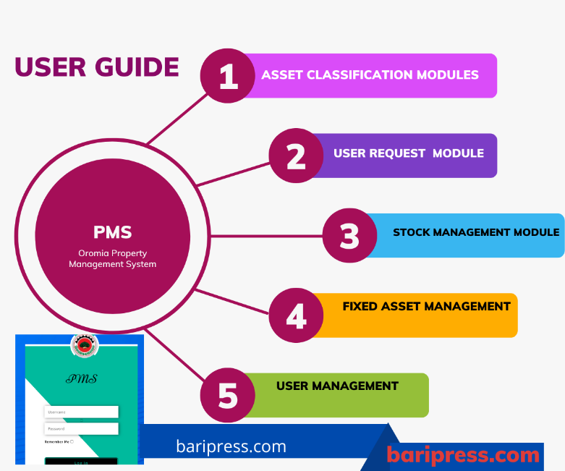

Contents

Oromia Property Management System 2

Actors/Participants of The System 3

Employee Activities 3

Basic Some PMS Modules 3

Flow of Pms Issue Request 4

User Request Management 5

Stock management Modules 5

Fixed Asset Management Module 5

Structural Level Manage 6

Main Steps Every one must Follows 7

Summary 8

Regarding roles /Roles and opening “accounts”. 8

# Oromia Property Management System

The procurement and Property Management System addresses the management of assets that range from fixed assets, short-term utilities, and long-term utilities. The software system is focused to enhancing the efficiency of asset management and strategically keeping track of assets by considering receive, issue, transfer and disposal transactions. The request from purchasing to asset issuing is also included.

Fixed assets, short-term utilities and long-term utilities report based on selected parameters is implemented in the project. Asset Depreciation for fixed assets is also one of the Modules to in the project. Procurement procedures are out of the scope for the project. Finally includes requests that comes from the user for purchase.

# Actors/Participants of The System

* Employee
* Director/department head
* PPO(Property Procurement Officer)
* Storekeeper
* PAO(Property Administrator Office)
* Store clerk

# Employee Activities

* Singin/singout
* Request
* Procurement request
* Issue Request
* Follow-up Request
* See his/her UC
* See all his/her receipt
* Change his/her password
* See request notifications
* Read and download user manual
* Read instruction or guidelines of PMS

# Basic Some PMS Modules

* + Asset Classification Modules.
  + User Request Management Modules.
  + Stock Management Modules.
  + Fixed Asset Management Modules
  + User Management Modules.
  + Report Modules
  + Setting Module

## Flow of Pms Issue Request

To make issue request you must follow the following steps

Step 1: Employee asks request to issue assets

Step 2: Director of the employee must approve the request

Step 3: Property Administrative Officer(PAO) Must approve the request

Step 4: Store Keeper Must process Register the request to transaction

Step 5: PAO must approve the transaction registered by storekeepers

Step 6: Store Clerk must approve the transaction that PAO approved

Step 7: final storekeeper must approve the transaction and give the asset to requested employee and print model off issue types.

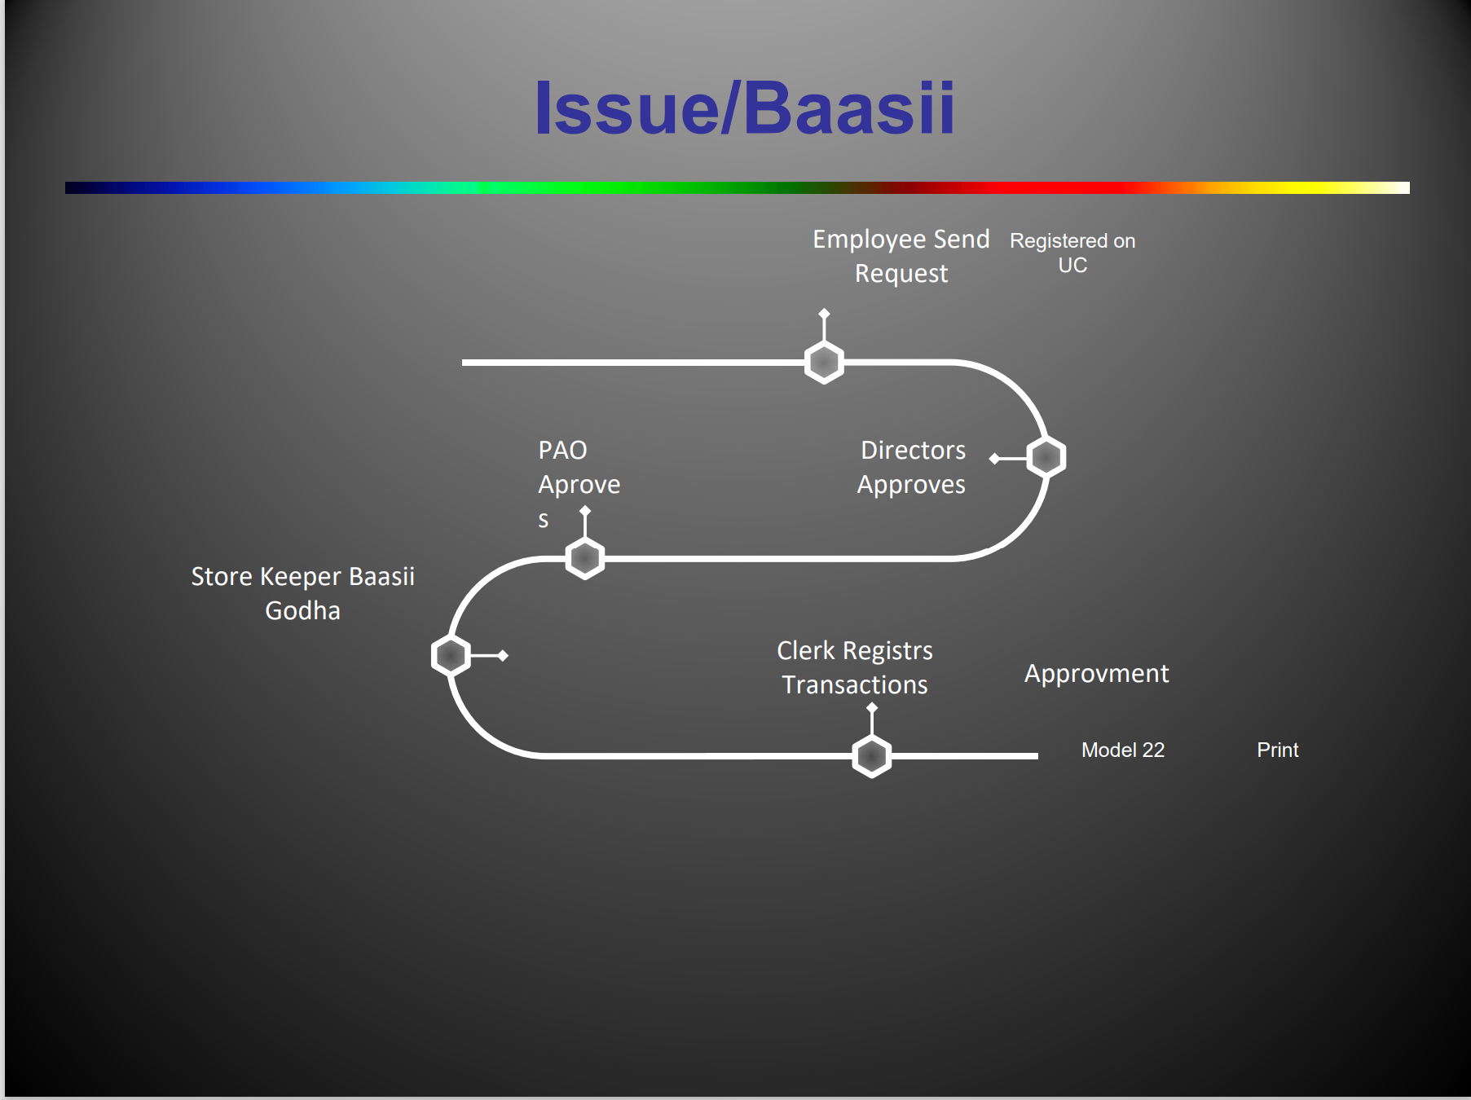

## User Request Management

The user request module contains three status

1. Waiting status
2. Approved status
3. Rejected status

## Stock management Modules

The stock management module is a module that controls asset in store that are not in hands of employees.

In this module there are five main functions

1. All Transaction
2. My Stock
3. My Asset
4. Stock Taking
5. My Store

## Fixed Asset Management Module

The fixed asset management module is a module that controls assets in hands of employees. In this modules there are 9 basic functions.

1. **FAR Registration**
2. **Return Item**
3. **Dispose Item**
4. **My User Card**
5. **User Card**
6. **Item History**
7. **Asset Profile**
8. **Asset Value**
9. **General Assets**

# Structural Level Manage

This system basically includes all structure hierarchy of Oromia government organizations from bureau to woreda levels.

Those structures system includes

1. Bureau Level: Oromia Finance Bureau at the top of the structures
2. All Oromia bureau’s other than Oromia finance bureau
3. Zone Level: that includes all sectors and offices under zone level administrations
4. City Level: That includes all sectors, subsectors and offices under city administration levels
5. Woreda level: that includes all woreda offices and sectors

**Rembers:** Any Organization that have above structure can use this system

# Main Steps Every one must Follows

**Steps**

**Admin tasks.**

**First Admin must create departments**

* under settings get the organization and click on the Plus button above the table.
* fill all the fields and save.

**\*Note:** when you create a department make sure the parent office is your bureau/your office. and please, select the corrorganizational structure.

For those who you are **city admins**, **zones**, and **woreda** you can create **sectors** as department structure.

**Second** Create all your bureau/office users under the departments you have created. employees must have created under his department correctly.

* create the following users under your bureau/office
* PPO
* PAO
* StoreClerk
* Storekeeper

Created Director under the belonging department.

**\*Note:** Give only one Group for users you will have create

create additional username as employee for those user act as your bureau/office that means for

* PPO
* PAO
* StoreClerk
* Storekeeper

**Third**: Admin must create Stores for your bureau/office

# Summary

**Houses Work Environment for the PMS.**

It is important to follow the guidelines below to implement a PMS.

## Regarding roles /Roles and opening “accounts”.

1. Enter the “setting” path and select the “Organization”. they say in the inside of the

* Name Director of the Office yours in existence creating a important is the

1. Login through “ **user management** ”and the “user” who they say prefer first the parents such as the Office in your own right at responsibility we create 'account” for those who have , They are :
2. **PAO (Property Administrative Officer)** ( Group Administration Resources )
3. **Store** keeper ( Storekeeper )
4. **Stockcrerk** ( professional Registrar and Controller Possession Stop )
5. **PPO ( Public Procurement Officer)** ( Process this power Shopping conducting the or directed by the director finance, procurement and administration possession for the given to the good will be )
6. Login through “ **user management** ”and the “user” who by selecting :
7. We create an ”account” for the director , ( **Note** : Office level in your own right power the director of the is given to him and , instead of “ office”. upon directed by the director their own for the preferred and so on instead of select structure Office in the department select )
8. Enter through “ **user management”** and select “user” to:
9. We create “accounts” for employees ( **Note**: Instead of “ office”. upon directed by the director there for the preferred and so on the select employee in the select structure field ) the force man of the workplace of yours name employees directed by the director their under the hood listed in the list by letter as for you gave the gift ask the question

**Note:-** The PAO, Store keeper,Stock clerk ,PPO and Director becoming were the characters in addition as and the employee is accounted open to him

1. **Regarding the registration of property**
2. First Register the working assets (ask the sectors to identify the working assets and provide them to you in writing)
3. Record the new purchases through systems and manuals and make revenue
4. Record the ones in the store that you can use immediately,
5. Remove equipment that is not in our service
6. Name equipment siistama among if you lost it note let us know by holding going _ **Work Good !!**

Note:This work is also done for the Districts in the same way

**Thank you For Reading**

**==============/////===========**

**Get In Touch by the following**

1. **Baripress t.me/baripress**
2. **Oromia PMS t.me/pmsnn**

**==========///By Dejene Kasa////============**